Assignment 1

Section A

3. What is data abstraction? Explain its levels.
Data abstraction is the process of hiding complex internal details of a database system and showing only the necessary information to users. It simplifies database interaction by allowing users to focus on what data is needed rather than how it is stored or managed.

It helps in reducing complexity and improving usability by separating different levels of detail.

Levels of Data Abstraction

- Physical Level (Internal Level)
- This is the lowest level of abstraction
- Describes how data is actually stored in the database
- Includes details like:
File organization
Storage structures
Indexing methods
- Used by database administrators (DBAs), not end users

- Logical Level (Conceptual Level)
- Describes what data is stored and the relationships between data
- Includes:
Tables
Attributes
Relationships
Constraints
- This is the level used by database designers

- View Level (External Level)
- The highest level of abstraction
- Shows only relevant data to specific users
- Different users can have different views of the same database
- Enhances security and simplicity
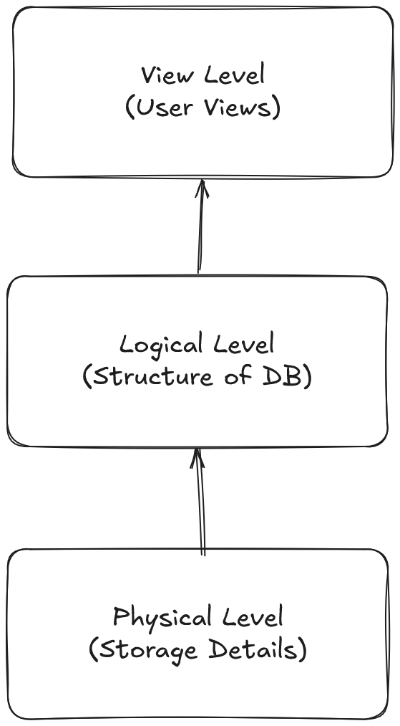

4. What is the three schema architecture? Why is it important?
The Three-Schema Architecture is a database design framework that separates the database into three levels: Internal, Conceptual, and External, to achieve data abstraction and independence.

It provides a structured way to organize data and manage interactions between users and the database system.

Levels in Three-Schema Architecture
- Internal Schema (Physical Level)
  - Defines how data is physically stored
  - Deals with storage structures, indexing, and access methods

- Conceptual Schema (Logical Level)
  - Represents the overall logical structure of the database
  - Includes entities, relationships, and constraints

- External Schema (View Level)
  - Represents user-specific views of the database
  - Each user sees only the data relevant to them

Importance

Data Independence
- Changes at one level do not affect other levels
- Example: Changing storage doesn’t affect user views

Security
- Users access only required data
- Simplifies Database Design
- Clear separation of concerns

Flexibility
- Easier to modify and maintain database

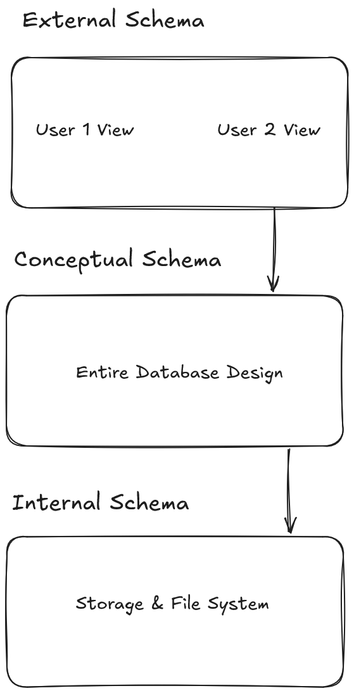
Section C

1. A hospital wants to store patient, doctor, and appointment data. Identify entities, attributes, and relationships.

Entities and Attributes

- Patient
- Patient_ID (Primary Key)
- Name
- Age
- Gender
- Contact

- Doctor
- Doctor_ID (Primary Key)
- Name
- Specialization
- Contact

- Appointment
- Appointment_ID (Primary Key)
- Date
- Time
- Patient_ID (Foreign Key)
- Doctor_ID (Foreign Key)

Relationships
- Patient → Appointment
  - One patient can have multiple appointments (1:M)
  - Each appointment belongs to one patient
- Doctor → Appointment
  - One doctor can have multiple appointments (1:M)
  - Each appointment is handled by one doctor

Constraints
- Patient_ID in Appointment must exist in Patient table (Referential Integrity)
- Doctor_ID in Appointment must exist in Doctor table
- Appointment must have valid date and time (Domain Constraint)
- Primary keys must be unique and not NULL (Entity Integrity)

2. An online shopping platform stores customer, product, and order data. Suggest keys and constraints.

Entities and Keys

- Customer
- Customer_ID (Primary Key)
- Name
- Address
- Contact

- Product
- Product_ID (Primary Key)
- Name
- Price

- Order
- Order_ID (Primary Key)
- Date
- Total_Amount
- Customer_ID (Foreign Key)

- Order_Item (Associative Entity)
- OrderItem_ID (Primary Key)
- Order_ID (Foreign Key)
- Product_ID (Foreign Key)
- Quantity

Constraints

Primary Keys
- Must be unique and not NULL

Foreign Keys
- Customer_ID in Order references Customer(Customer_ID)
- Order_ID in Order_Item references Order(Order_ID)
- Product_ID in Order_Item references Product(Product_ID)

Referential Integrity
- Orders cannot exist without a valid customer
- Order items cannot exist without valid order and product

Domain Constraints
- Price must be positive
- Quantity must be greater than zero

Key Constraints
- Combination of Order_ID and Product_ID can be unique in Order_Item to avoid duplicates

3. A university stores student records. Explain how data abstraction helps different users.
Data abstraction helps different users interact with the database according to their needs without exposing unnecessary complexity. It provides different levels of data visibility and simplifies database usage.

Explanation using levels

- View Level (External Level)
- End users such as students, faculty, and administrative staff interact at this level
- Each user sees only relevant data
  - Students can view their grades and personal details
  - Faculty can access student lists and performance
- Ensures security and simplicity

- Logical Level (Conceptual Level)
- Used by database designers and administrators
- Defines structure of the database
  - Student table, course table, relationships
- Users do not need to know how data is physically stored

- Physical Level (Internal Level)
- Used by system administrators
- Describes how data is stored in memory or disk
  - File structures, indexing, storage allocation
- Hidden from end users

